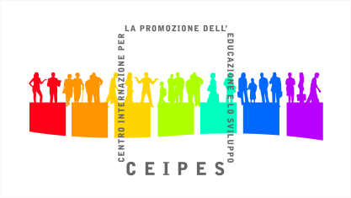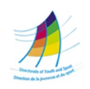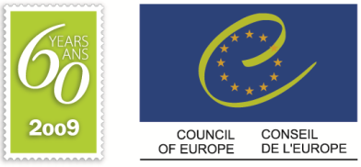



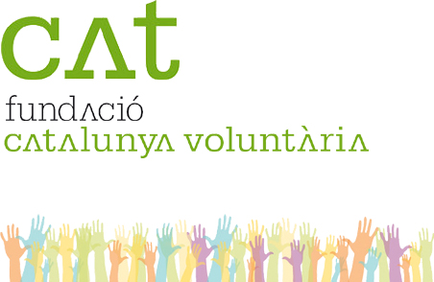

**International conference**

**The role of young people in peacebuilding and social change:**

**good practices and future perspectives**

**Palermo 20-25 November 2012**

Organized by:

CEIPES – International centre for the Promotion of Education and development

Via G. La farina 21 – 90141 Palermo, Italy

*‘CEIPES is a non-profit global organization active at social and human development through education in a world of peace and equality where each person has own human rights fulfilled.*

*The mission of CEIPES is to foster and support the sustainable development of local communities and individuals’ empowerment through education and training, human rights and international cooperation.’*

In cooperation with UNOY Peacebuilders (Netherlands), Fundacion Catalunya Voluntaria (Spain) and PATRIR (Romania).

With financial support from the European Youth Foundation from the Council of Europe.

**Call for participants**

**Aims and working programme**

**The international conference aims to** create a space where young people can share their experiences in peacebuilding and human rights education and to propel young people spirits to the task of peacebuilding with a special focus on arts.

|  |  |  |  |  |
| --- | --- | --- | --- | --- |
|  | **Morning** | **Afternoon** |  | **Evening** |
| **Day 1**  **20 Nov** | ARRIVALS | 17.00-Team building and knowing each other |  | Welcome evening |
| **Day 2**  **21 Nov** | Presentations  Introduction to the project and programme of the conference  Expectations and motivations | Peace and culture of Peace | Daily evaluation | Evening of cultures |
| **Day 3**  **22 Nov** | Parallel workshops:  Peace through dance  Peace through music | Continuation of the workshops) | Free time |
| **Day 4**  **23 Nov** | Tool Fair of Peace:  Experiential workshops | Field visit to a local NGO | Free time |
| **Day 5**  **24 Nov** | Follow up of the project | Evaluation (cont.)  Closure of the conference |  |
| **Day 6**  **25 Nov** | DEPARTURES |  |  |  |

**Educational approach**

We plan to unite diverse pedagogical and didactical approaches, all in the framework of non-formal education.

We will use is a learner-centred approach with the aim to shape learning as far as possible in accordance with the needs of adult learners (interests, local reality, and previous knowledge). We will create conditions in which learners can collaborate with each other, ask their own questions and evaluate their own learning goals.

We want to focus our workshop on active participations and for this we will use active and participatory methodology (small working groups, roles plays, simulation activities etc.).

The meeting will be developed in a non-formal education context based in a peace education approach that uses a learning by doing methodology, dialogue and communication, participatory learning process using participants experiences, active listening, reflection and cooperation.

We chose working methods and built up a program flow (process), which is based mainly on participants needs and in their active involvement; these methods trigger the non-formal education process. A variety of methods and the complexity of each method in itself ensure that all participants are able to engage in the learning process by using their own privileged learning channels. As well, the fact that participants are actively participating allows them to develop several skills, as well as to learn tools and competences.

**Participants’ profile**

* Young people aged 18-30
* Young people interested and motivated to contribute to peacebuilding and human rights culture in a long-term perspective.
* Young participants should be available to take part in the entire seminar.
* Young people who are available to act as multipliers.
* Medium-high level of English speaking.

**How to apply**

Please, send a short motivation letter answering the following questions:

1: What are main aims of your organization, related to the topic of International Conference?   
2: What is your previous experience in peacebuilding, social change and human rights education actions?  
3: Why would you like to take part in the International Conference?  
4: What kind of advantages will you take from taking part in it?  
5: After the end of the International Conference, what would be your direction of action in topics of peacebuilding and human rights education?

**All selected participants will be asked to prepare a presentation about a good practice OR a project OR an activity in the framework of peacebuilding and/or human rights education, which will be presented during the conference.**

**If you would like to participate please send the motivation letter to Marta Borkowska via e-mail** [**internship@ceipes.org**](mailto:internship@ceipes.org) **until the 22nd of October.**

**Participation costs**

* Food and accommodation will be covered 100%
* Participants fee: 50€ do be discounted in the travel reimbursement
* Travel will be reimbursed 2/3 of total cost
* Visa costs will be covered 2/3 of total costs
* Insurance is not covered